
[Titus]
[Matandaware]
[ST10539510]
[My Chosen Proposal]
[Love fromAbove NPO]

[WEB DEDEVELOPMENT(introduction) 5020w]
[WEDE5020_part1]

Name of Organization: Love From Above

Category: non-profit Organization(NPO)

ORGANIZATION OVERVIEW

This organization is a community-based non-profit organization based in Ormonde, Johannesburg South. It has been slowly making waves of change since its inception in 2021. Its mission and vision lies in empowering individuals within communities to take charge of their own development. The organization’s founders, a group of individuals who recognized the gaps in services and resources within their community, came together to address these needs. The target audience of this establishment are the local community members seeking assistance. Potential donors and sponsors, volunteers looking for opportunities to serve and maybe NGOs looking for collaborations.

Website goals and objectives
. Share information about services and initiatives.
· Provide easy access to enquiries and contact forms.
· Showcase services offered to the community.
· Encourage donations and volunteer sign-ups.
· Build credibility and transparency through project updates.

Current website analysis
Love from Above NPO does not have a dedicated website currently. Information is shared via word-of-mouth and social media, which limits reach and credibility. A professional website will centralize communication and improve visibility and credibility.
Proposed website features and functionality
· Homepage (Index): Mission statement, hero image, quick links.
· About Us: History, vision, and team profiles.
· Services: Detailed list of community support, education, and health-care services.
· Enquiries: Online enquiry form for questions and requests.
· Contact Us: Location map, contact form, and social media links.
· Projects/Impact : Showcase current and past initiatives with images and stories.
Design and user experience
• Clean, welcoming design with warm colors (symbolizing care and compassion).
• Responsive layout for mobile and desktop.
• Simple navigation clear labels.
• Logo prominently displayed in the header.
Wireframes
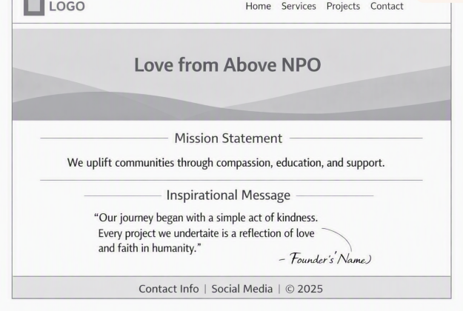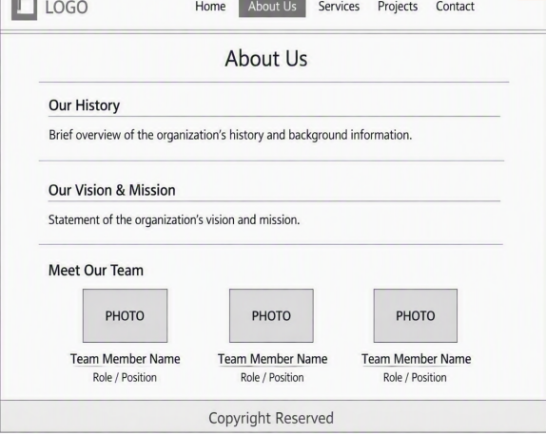
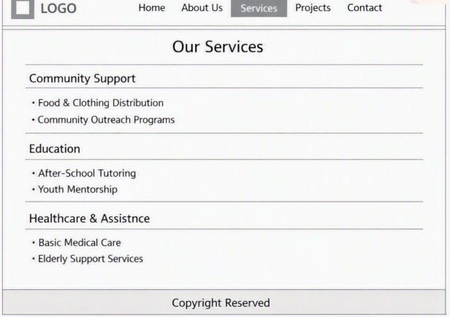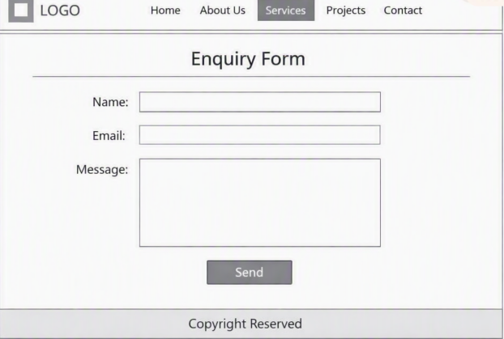
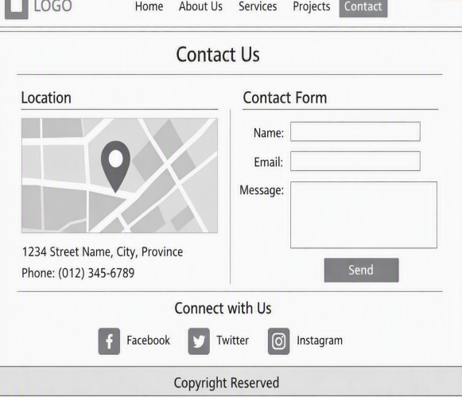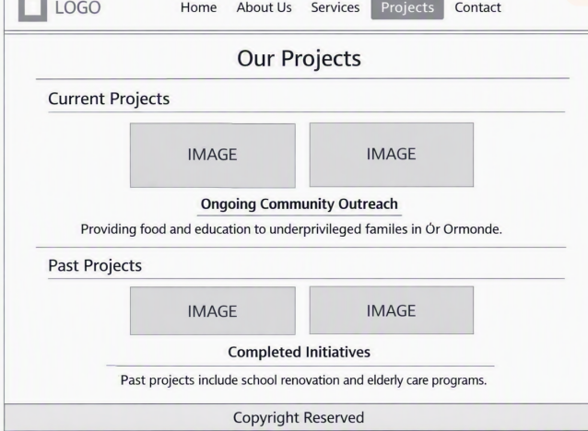
Technical requirements
• HTML5, CSS3, and JavaScript for structure, styling, and interactivity.
• Responsive framework (e.g., Bootstrap).
• Hosting with SSL certificate(to ensure that there is a secure communication between the website and and the visitors) for security.
• Integration with a payment gateway for donations.
• Contact and enquiry forms with basic validation.
Timeline
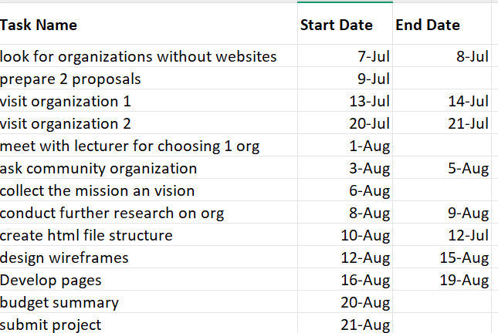
Budget
* Domain registering(.co.za) and hosting: R200 - R300 annually
*SSL certificate: R300+ annually or can be free via[LE]
*Maintenance: R500 monthly
Total(est)=R21000 for 1st year costs
References
IIE mOdule manual [WEDE5020]
https://www.nngroup.com/articles/nonprofit-usability/
https://www.afrihost.com
Gift of the Givers Foundation (2025) Digital Outreach and Community Impact Report. Cape Town: Gift of the Givers Foundation.

